TRAINING AND PLACEMENT CELL
ACADEMIC YEAR 2024-2025
MSME ENTREPRENEURSHIP AWARENESS PROGRAMME on 29.01.2025
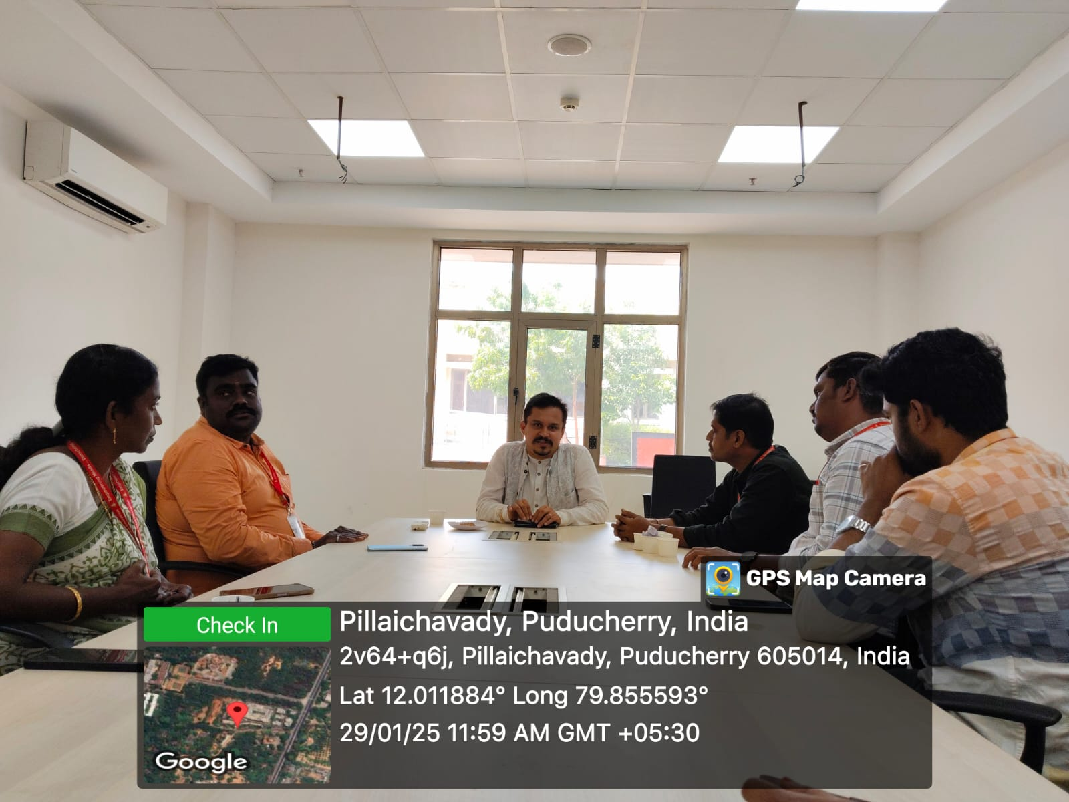
The Training & Placement Cell of AASC arranged a One-Day (29.01.25) Entrepreneurship Awareness Programme (EAP) by Micro, Small and Medium Enterprises (MSME) for all UG Final Year Students. This Entrepreneurship and Skill Development Program was Conducted by MSME - Development and Facilitation Office (DFOs), Puducherry. The aspiring students who are interested in starting new business and who want to be an entrepreneur got benefited by this session.

